Monday 5th February 2024
L.O - To represent a 2-digit number within 50 as tens and ones on a place value chart
I can group in tens
I recognise one groups of ten is the same as 10
I can represent my number in different ways
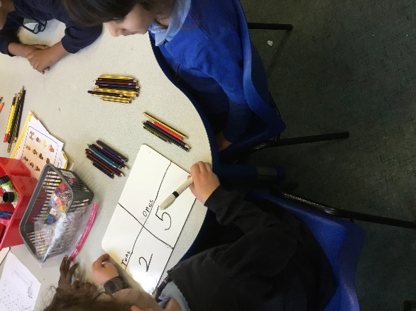
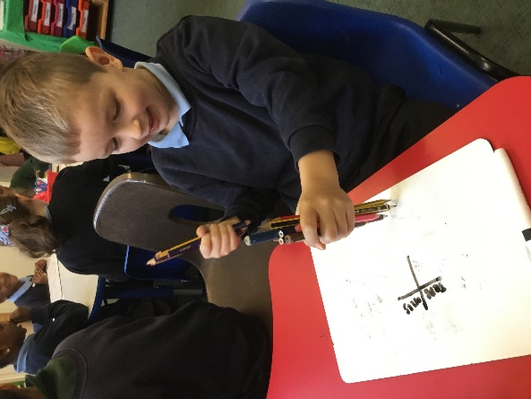
We had lots of pencils in the class to count, so the children helped by grouping them into tens. This made counting them easier. Then the children represented this number in different ways, for example using cubes, beadstrings or recording the number in a table.
